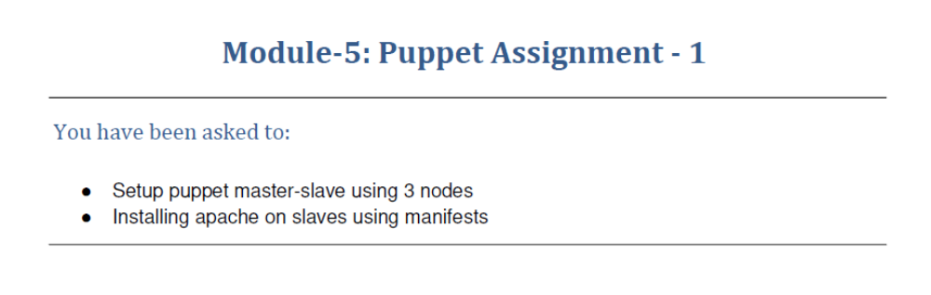
ubuntu@ip-172-31-7-162:~$ sudo puppet cert list
/usr/lib/ruby/vendor_ruby/puppet/util.rb:461: warning: URI.escape is obsolete
/usr/lib/ruby/vendor_ruby/puppet/util.rb:461: warning: URI.escape is obsolete
/usr/lib/ruby/vendor_ruby/puppet/util.rb:461: warning: URI.escape is obsolete
/usr/lib/ruby/vendor_ruby/puppet/util.rb:461: warning: URI.escape is obsolete
/usr/lib/ruby/vendor_ruby/puppet/util.rb:315: warning: deprecated Object#=~ is called on Puppet::Transaction::Report; it always returns nil
/usr/lib/ruby/vendor_ruby/puppet/util.rb:461: warning: URI.escape is obsolete
/usr/lib/ruby/vendor_ruby/puppet/util.rb:461: warning: URI.escape is obsolete
/usr/lib/ruby/vendor_ruby/puppet/util.rb:461: warning: URI.escape is obsolete
Warning: `puppet cert` is deprecated and will be removed in a future release.
(location: /usr/lib/ruby/vendor_ruby/puppet/application.rb:370:in `run')
"ip-172-31-1-85.us-east-2.compute.internal" (SHA256) E0:86:B2:98:6F:EB:14:CE:F2:E7:D9:90:2D:65:78:22:21:22:C6:69:BC:8E:48:A4:EA:AE:94:74:EB:1A:62:D0
"ip-172-31-15-19.us-east-2.compute.internal" (SHA256) BD:73:28:D0:B2:D1:CF:A6:60:75:90:C4:66:7D:B4:A1:06:3F:88:BF:01:64:19:B0:41:E6:DA:EF:F1:20:AA:2F
ubuntu@ip-172-31-7-162:~$ sudo puppet cert sign --all
/usr/lib/ruby/vendor_ruby/puppet/util.rb:461: warning: URI.escape is obsolete
/usr/lib/ruby/vendor_ruby/puppet/util.rb:461: warning: URI.escape is obsolete
/usr/lib/ruby/vendor_ruby/puppet/util.rb:461: warning: URI.escape is obsolete
/usr/lib/ruby/vendor_ruby/puppet/util.rb:461: warning: URI.escape is obsolete
/usr/lib/ruby/vendor_ruby/puppet/util.rb:315: warning: deprecated Object#=~ is called on Puppet::Transaction::Report; it always returns nil
/usr/lib/ruby/vendor_ruby/puppet/util.rb:461: warning: URI.escape is obsolete
/usr/lib/ruby/vendor_ruby/puppet/util.rb:461: warning: URI.escape is obsolete
/usr/lib/ruby/vendor_ruby/puppet/util.rb:461: warning: URI.escape is obsolete
Warning: `puppet cert` is deprecated and will be removed in a future release.
(location: /usr/lib/ruby/vendor_ruby/puppet/application.rb:370:in `run')
Signing Certificate Request for:
"ip-172-31-15-19.us-east-2.compute.internal" (SHA256) BD:73:28:D0:B2:D1:CF:A6:60:75:90:C4:66:7D:B4:A1:06:3F:88:BF:01:64:19:B0:41:E6:DA:EF:F1:20:AA:2F
Notice: Signed certificate request for ip-172-31-15-19.us-east-2.compute.internal
Notice: Removing file Puppet::SSL::CertificateRequest ip-172-31-15-19.us-east-2.compute.internal at '/var/lib/puppet/ssl/ca/requests/ip-172-31-15-19.us-east-2.compute.internal.pem'
Signing Certificate Request for:
"ip-172-31-1-85.us-east-2.compute.internal" (SHA256) E0:86:B2:98:6F:EB:14:CE:F2:E7:D9:90:2D:65:78:22:21:22:C6:69:BC:8E:48:A4:EA:AE:94:74:EB:1A:62:D0
Notice: Signed certificate request for ip-172-31-1-85.us-east-2.compute.internal
Notice: Removing file Puppet::SSL::CertificateRequest ip-172-31-1-85.us-east-2.compute.internal at '/var/lib/puppet/ssl/ca/requests/ip-172-31-1-85.us-east-2.compute.internal.pem'
ubuntu@ip-172-31-7-162:~$ sudo mkdir -p /etc/puppet/code/environments/production/manifests
ubuntu@ip-172-31-7-162:~$ sudo nano /etc/puppet/code/environments/production/manifests/site.pp
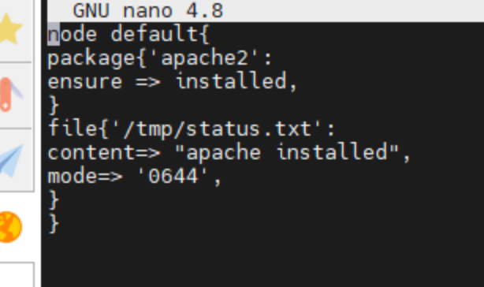
ubuntu@ip-172-31-7-162:~$ sudo systemctl restart puppet-master
ubuntu@ip-172-31-7-162:~$ sudo nano /etc/puppet/code/environments/production/manifests/site.pp
ubuntu@ip-172-31-7-162:~$ sudo systemctl restart puppet-master

On slave-1
ubuntu@ip-172-31-15-19:~$ sudo puppet agent --test
/usr/lib/ruby/vendor_ruby/puppet/util.rb:461: warning: URI.escape is obsolete
/usr/lib/ruby/vendor_ruby/puppet/util.rb:461: warning: URI.escape is obsolete
/usr/lib/ruby/vendor_ruby/puppet/util.rb:461: warning: URI.escape is obsolete
/usr/lib/ruby/vendor_ruby/puppet/util.rb:461: warning: URI.escape is obsolete
/usr/lib/ruby/vendor_ruby/puppet/util.rb:315: warning: deprecated Object#=~ is called on Puppet::Transaction::Report; it always returns nil
/usr/lib/ruby/vendor_ruby/puppet/util.rb:461: warning: URI.escape is obsolete
/usr/lib/ruby/vendor_ruby/puppet/util.rb:461: warning: URI.escape is obsolete
/usr/lib/ruby/vendor_ruby/puppet/util.rb:461: warning: URI.escape is obsolete
/usr/lib/ruby/vendor_ruby/puppet/util.rb:315: warning: deprecated Object#=~ is called on Puppet::Transaction::Report; it always returns nil
/usr/lib/ruby/vendor_ruby/puppet/util.rb:461: warning: URI.escape is obsolete
Info: Using configured environment 'production'
Info: Retrieving pluginfacts
/usr/lib/ruby/vendor_ruby/puppet/util.rb:461: warning: URI.escape is obsolete
/usr/lib/ruby/vendor_ruby/puppet/util.rb:315: warning: deprecated Object#=~ is called on Puppet::Transaction::Report; it always returns nil
/usr/lib/ruby/vendor_ruby/puppet/util.rb:461: warning: URI.escape is obsolete
/usr/lib/ruby/vendor_ruby/puppet/indirector/request.rb:272: warning: URI.unescape is obsolete
/usr/lib/ruby/vendor_ruby/puppet/util.rb:461: warning: URI.escape is obsolete
Info: Retrieving plugin
/usr/lib/ruby/vendor_ruby/puppet/util.rb:461: warning: URI.escape is obsolete
/usr/lib/ruby/vendor_ruby/puppet/util.rb:315: warning: deprecated Object#=~ is called on Puppet::Transaction::Report; it always returns nil
/usr/lib/ruby/vendor_ruby/puppet/util.rb:461: warning: URI.escape is obsolete
/usr/lib/ruby/vendor_ruby/puppet/indirector/request.rb:272: warning: URI.unescape is obsolete
/usr/lib/ruby/vendor_ruby/puppet/util.rb:461: warning: URI.escape is obsolete
Info: Retrieving locales
/usr/lib/ruby/vendor_ruby/puppet/util.rb:461: warning: URI.escape is obsolete
/usr/lib/ruby/vendor_ruby/puppet/util.rb:315: warning: deprecated Object#=~ is called on Puppet::Transaction::Report; it always returns nil
/usr/lib/ruby/vendor_ruby/puppet/util.rb:461: warning: URI.escape is obsolete
/usr/lib/ruby/vendor_ruby/puppet/indirector/request.rb:272: warning: URI.unescape is obsolete
/usr/lib/ruby/vendor_ruby/puppet/util.rb:461: warning: URI.escape is obsolete
/usr/lib/ruby/vendor_ruby/puppet/util.rb:461: warning: URI.escape is obsolete
Info: Caching catalog for ip-172-31-15-19.us-east-2.compute.internal
/usr/lib/ruby/vendor_ruby/puppet/file_system/uniquefile.rb:126: warning: $SAFE will become a normal global variable in Ruby 3.0
/usr/lib/ruby/vendor_ruby/puppet/util.rb:461: warning: URI.escape is obsolete
/usr/lib/ruby/vendor_ruby/puppet/util.rb:461: warning: URI.escape is obsolete
/usr/lib/ruby/vendor_ruby/puppet/util.rb:461: warning: URI.escape is obsolete
Info: Applying configuration version '1638719592'
Notice: /Stage[main]/Main/Node[default]/Package[apache2]/ensure: created
/usr/lib/ruby/vendor_ruby/puppet/file_system/uniquefile.rb:126: warning: $SAFE will become a normal global variable in Ruby 3.0
/usr/lib/ruby/vendor_ruby/puppet/file_system/uniquefile.rb:126: warning: $SAFE will become a normal global variable in Ruby 3.0
Notice: Applied catalog in 12.37 seconds
/usr/lib/ruby/vendor_ruby/puppet/file_system/uniquefile.rb:126: warning: $SAFE will become a normal global variable in Ruby 3.0
/usr/lib/ruby/vendor_ruby/puppet/util.rb:461: warning: URI.escape is obsolete
/usr/lib/ruby/vendor_ruby/puppet/file_system/uniquefile.rb:126: warning: $SAFE will become a normal global variable in Ruby 3.0
ubuntu@ip-172-31-15-19:~$ cat /tmp/status.txt
apache installed
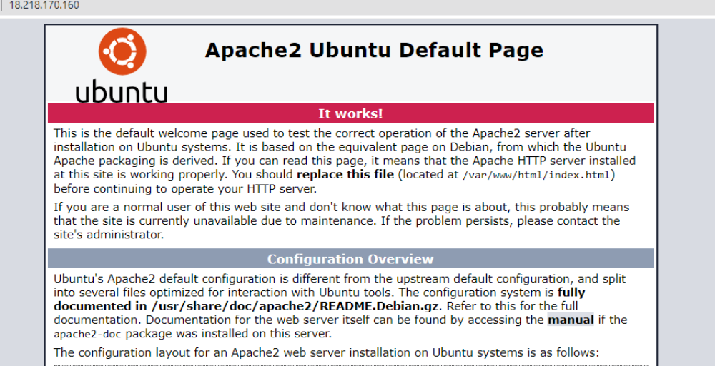
On Slave-2
ubuntu@ip-172-31-1-85:~$ sudo puppet agent --test
/usr/lib/ruby/vendor_ruby/puppet/util.rb:461: warning: URI.escape is obsolete
/usr/lib/ruby/vendor_ruby/puppet/util.rb:461: warning: URI.escape is obsolete
/usr/lib/ruby/vendor_ruby/puppet/util.rb:461: warning: URI.escape is obsolete
/usr/lib/ruby/vendor_ruby/puppet/util.rb:461: warning: URI.escape is obsolete
/usr/lib/ruby/vendor_ruby/puppet/util.rb:315: warning: deprecated Object#=~ is called on Puppet::Transaction::Report; it always returns nil
/usr/lib/ruby/vendor_ruby/puppet/util.rb:461: warning: URI.escape is obsolete
/usr/lib/ruby/vendor_ruby/puppet/util.rb:461: warning: URI.escape is obsolete
/usr/lib/ruby/vendor_ruby/puppet/util.rb:461: warning: URI.escape is obsolete
/usr/lib/ruby/vendor_ruby/puppet/util.rb:315: warning: deprecated Object#=~ is called on Puppet::Transaction::Report; it always returns nil
/usr/lib/ruby/vendor_ruby/puppet/util.rb:461: warning: URI.escape is obsolete
Info: Using configured environment 'production'
Info: Retrieving pluginfacts
/usr/lib/ruby/vendor_ruby/puppet/util.rb:461: warning: URI.escape is obsolete
/usr/lib/ruby/vendor_ruby/puppet/util.rb:315: warning: deprecated Object#=~ is called on Puppet::Transaction::Report; it always returns nil
/usr/lib/ruby/vendor_ruby/puppet/util.rb:461: warning: URI.escape is obsolete
/usr/lib/ruby/vendor_ruby/puppet/indirector/request.rb:272: warning: URI.unescape is obsolete
/usr/lib/ruby/vendor_ruby/puppet/util.rb:461: warning: URI.escape is obsolete
Info: Retrieving plugin
/usr/lib/ruby/vendor_ruby/puppet/util.rb:461: warning: URI.escape is obsolete
/usr/lib/ruby/vendor_ruby/puppet/util.rb:315: warning: deprecated Object#=~ is called on Puppet::Transaction::Report; it always returns nil
/usr/lib/ruby/vendor_ruby/puppet/util.rb:461: warning: URI.escape is obsolete
/usr/lib/ruby/vendor_ruby/puppet/indirector/request.rb:272: warning: URI.unescape is obsolete
/usr/lib/ruby/vendor_ruby/puppet/util.rb:461: warning: URI.escape is obsolete
Info: Retrieving locales
/usr/lib/ruby/vendor_ruby/puppet/util.rb:461: warning: URI.escape is obsolete
/usr/lib/ruby/vendor_ruby/puppet/util.rb:315: warning: deprecated Object#=~ is called on Puppet::Transaction::Report; it always returns nil
/usr/lib/ruby/vendor_ruby/puppet/util.rb:461: warning: URI.escape is obsolete
/usr/lib/ruby/vendor_ruby/puppet/indirector/request.rb:272: warning: URI.unescape is obsolete
/usr/lib/ruby/vendor_ruby/puppet/util.rb:461: warning: URI.escape is obsolete
/usr/lib/ruby/vendor_ruby/puppet/util.rb:461: warning: URI.escape is obsolete
Info: Caching catalog for ip-172-31-1-85.us-east-2.compute.internal
/usr/lib/ruby/vendor_ruby/puppet/file_system/uniquefile.rb:126: warning: $SAFE will become a normal global variable in Ruby 3.0
/usr/lib/ruby/vendor_ruby/puppet/util.rb:461: warning: URI.escape is obsolete
/usr/lib/ruby/vendor_ruby/puppet/util.rb:461: warning: URI.escape is obsolete
/usr/lib/ruby/vendor_ruby/puppet/util.rb:461: warning: URI.escape is obsolete
Info: Applying configuration version '1638719625'
Notice: /Stage[main]/Main/Node[default]/Package[apache2]/ensure: created
/usr/lib/ruby/vendor_ruby/puppet/file_system/uniquefile.rb:126: warning: $SAFE will become a normal global variable in Ruby 3.0
Notice: /Stage[main]/Main/Node[default]/File[/tmp/status.txt]/ensure: defined content as '{md5}d880fa7cdc620f6fa5ce7b4464404f23'
/usr/lib/ruby/vendor_ruby/puppet/file_system/uniquefile.rb:126: warning: $SAFE will become a normal global variable in Ruby 3.0
/usr/lib/ruby/vendor_ruby/puppet/file_system/uniquefile.rb:126: warning: $SAFE will become a normal global variable in Ruby 3.0
Notice: Applied catalog in 11.71 seconds
/usr/lib/ruby/vendor_ruby/puppet/file_system/uniquefile.rb:126: warning: $SAFE will become a normal global variable in Ruby 3.0
/usr/lib/ruby/vendor_ruby/puppet/util.rb:461: warning: URI.escape is obsolete
/usr/lib/ruby/vendor_ruby/puppet/file_system/uniquefile.rb:126: warning: $SAFE will become a normal global variable in Ruby 3.0
ubuntu@ip-172-31-1-85:~$ cat /tmp/status.txt
apache installed
